**Classroom Activity: Create a React application that displays the population of countries using an API**

**Step 1:**

Create a new React application using the following command in vs code terminal.

* npx create-react-app country-population
* cd country-population

**Step 2:**

**Install Axios for API Requests**

* npm install axios

**Step 3:**

Create a **components** directory and **CountryPopulation.js** to Fetch and Display Data.

Additionally, create a **style.css** file for styling the components.

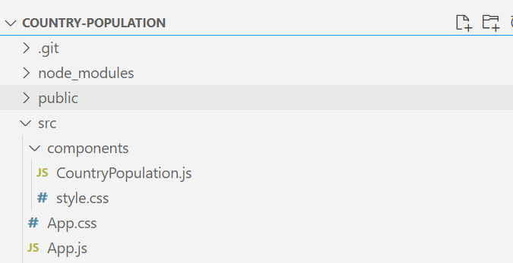

Figure: country-population Program Structure’s Screenshot

**Code:**

File Name: src/components/CountryPopulation.js

|  |
| --- |
| import React, { useState } from 'react';  import axios from 'axios';  import './style.css'  const CountryPopulation = () => {    const [countryName, setCountryName] = useState('');    const [population, setPopulation] = useState(null);    const [loading, setLoading] = useState(false);    const [error, setError] = useState(null);    const fetchPopulation = () => {      setLoading(true);      setError(null);      axios.get(`https://restcountries.com/v3.1/name/${countryName}`)        .then(response => {          const country = response.data[0];          setPopulation(country.population);          setLoading(false);        })        .catch(error => {          setError(error);          setLoading(false);        });    };    const handleInputChange = (e) => {      setCountryName(e.target.value);    };    const handleSubmit = (e) => {      e.preventDefault();      fetchPopulation();    };    return (      <div>          <div>              <h1>Country Population</h1>              <form onSubmit={handleSubmit}>              <input              type="text"              value={countryName}              onChange={handleInputChange}              placeholder="Enter country name"              />              <button type="submit">Get Population</button>              </form>          </div>          <div className='output_div'>              {loading && <p>Loading...</p>}              {error && <p>Error: {error.message}</p>}              {population !== null && <p>Population of {countryName}: {population.toLocaleString()}</p>}          </div>      </div>    );  };  export default CountryPopulation; |

File Name: src/App.js

import CountryPopulation from './components/CountryPopulation';

import './App.css';

function App() {

  return (

    <div className="App">

      <CountryPopulation />

    </div>

  );

}

export default App;

File Name: src/App.css

|  |
| --- |
| .App {    text-align: center;    padding: 20px;  }  h1 {    margin: 20px 0;  }  form {    margin: 20px 0;  }  input {    padding: 8px;    font-size: 16px;    border: 1px solid #ccc;    border-radius: 4px;  }  button {    padding: 8px 12px;    margin-left: 10px;    font-size: 16px;    background-color: #4CAF50;    color: white;    border: none;    border-radius: 4px;    cursor: pointer;  }  button:hover {    background-color: #45a049;  }  p {    font-size: 18px;    margin: 10px 0;  }  div {    display: flex;    flex-direction: column;    align-items: center;  } |

File Name: src/components/style.css

|  |
| --- |
| .output_div {      margin-top: 20px;      padding: 10px;      border: 1px solid #290b0b;      border-radius: 4px;      width: 50%;      background-color: #8dd786;    }      .output_div p {      margin: 5px 0;    } |

**OUTPUT:**

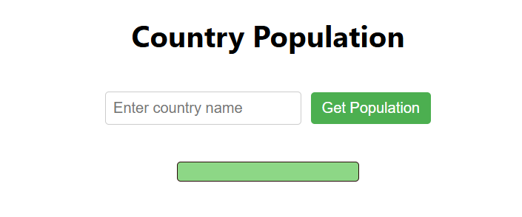

Figure: Output Screenshot 1

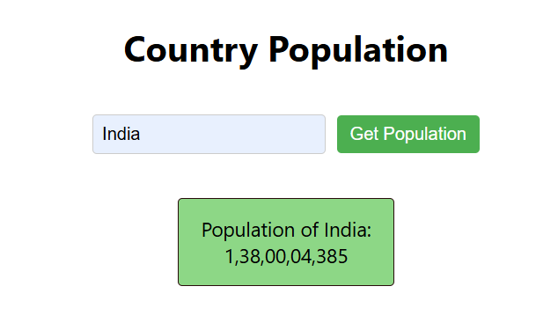

Figure: Output Screenshot 2

**Execution Steps:**

* Go to VS Code terminal
* Execute the following command to run the program:
* npm start
* This will open your default browser and navigate to http://localhost:3000, where you will see your new React application running.